Sentiment Analysis of Movie Reviews Using Updated Neural network Approach

A PROJECT REVIEW REPORT - I

Submitted by
DEVANSH NEMA (Reg no: RA1511003010032)
DEVANSH BHUDOLIA (Reg no: RA1511003010076)

in partial fulfillment of the requirements for the degree
Of

BACHELOR OF TECHNOLOGY
Under the guidance of
Ms. R. ANITA

(Assistant Professor, Department of Computer Science and Engineering)


DEPARTMENT OF COMPUTER SCIENCE AND ENGINEERING

FACULTY OF ENGINEERING AND TECHNOLOGY
SRM INSTITUTE OF SCIENCE AND TECHNOLOGY
KATTANKULATHUR- 603 203
FEBRUARY 2019

SRM Institute of Science and Technology

(Under Section 3 of UGC Act, 1956)

BONAFIDE CERTIFICATE

Certified that this project report titled “Sentiment Analysis of Movie Reviews Using Updated Neural network Approach” is the bonafide work of “DEVANSH NEMA [Reg No: RA1511003010032], DEVANSH BHUDOLIA [Reg No: RA1511003010076]”, who carried out the project work under my supervision. Certified further, that to the best of my knowledge the work reported herein does not form any other project report or dissertation on the basis of which a degree or award was conferred on an earlier occasion on this or any other candidate.

SIGNATURE SIGNATURE

Ms. R. ANITA Dr. B. AMUTHA

GUIDE HEAD OF THE DEPARTMENT
Asst Professor Dept. of Computer Science &
Dept. of Computer Science Engineering
& Engineering

Signature of the Internal Examiner Signature of the External Examiner

ABSTRACT

Semantics is the study of the meaning of linguistic utterances. For their need people are always eager to know other's reviews but, each and every website contains a very huge amount of review text, the normal human reader will have problem in identifying relevant sites, extracting and abstracting the reviews, so they cannot reach to the right decision in less time that is why automated sentiment analysis systems are needed.
Sentiment analysis is an application of text analysis and Natural Language Processing (NLP) which helps to identify the emotions in a given context. Before making decisions for watching movies people usually ask for advises. It’s convenient if user opinions can be automatically aggregated and analyzed. To obtain an exact rating of a movie, sentiment rating can be formulated as a regression problem. Sentiment analysis of a movie review plays an important role in understanding the sentiment conveyed by the user towards the movie.
Since our goal is only an overall suggestion of worthwhile or not, neural network based sentiment classification is used in this paper. In this paper we introduce an updated algorithm.

ACKNOWLEDGEMENTS

I would like to take this opportunity to express my deepest gratitude to our guide, Ms.
R. ANITA for her valuable guidance, consistent encouragement, personal caring, timely help and providing us with an excellent atmosphere for the successful completion of our project. We would like to thank Dr. C.N. Subhlalitha, Project Coordinator for her valuable support and guidance. We would also like to thank our class in charge Mr. T. Senthil Kumar for her constant support. Lastly, we would like to thank the entire Department of Computer Science and Engineering for the constant support, encouragement and motivation without which the completion of this project would not have been possible.

Authors

TABLE OF CONTENTS
CHAPTER NO. TITLE PAGE NO.
ABSTRACT v
LIST OF TABLES xiii
LIST OF FIGURES xv
LIST OF SYMBOLS AND ABBREVIATIONS xxvii
1 INTRODUCTION 1 1.1 About project 2
2 LITERATURE SURVEY
2.1 Comparison of Four Text Classifiers on Movie
Reviews
2.2 Improving Sentiment Rating of Movie Review
Comment for Recommendation
2.3 Sentiment Analysis of Movie Reviews Using
Heterogeneous Features
2.4 Aanalysis of movie reviews using lexicon approach
2.5 Sentiment Classiﬁcation of Film Reviews Using IB1
2.6 Enhancing the Performance of Sentiment Analysis by
Using Different Feature Combinations
2.7 Sentiment analyis of Indian movie review with
various feature selection techniques
2.8 Sentiment analysis of movie review data using
Senti-lexicon algorithm
2.9 SentReP: Sentiment Classiﬁcation of Movie Reviews
using Efficient Repetitive Pre-Processing
2.10 Aspect Based Sentiment Analysis of Movie Reviews:
Finding the Polarity Directing Aspects

3 MODULES 27
3.1 Dataset
3.2 Artificial Neural Network (ANN)
4 EXISTING SYSYTEM 18
4.1 DISADVANTAGES………………………………… 18
5 PRAPOSED SYSTEM | 20
5.1 Advantages . . . . . . . . . . . . . . . . . . . . . . . . . . . . . . | 21
5.2 Hardware Requirements . . . . . . . . . . . . . . . . . . . . . . . | 22
5.3 Software Requiremnets . . . . . . . . . . . . . . . . . . . . . . . . | 22
6 SYSTEM ANALYSIS | 23
7 SYSTEM DESIGN | 24
7.1 Architechture Design . . . . . . . . . . . . . . . . . . . . . . . . . | 24
7.2 Proposed Modules . . . . . . . . . . . . . . . . . . . . . . . . . . 25

 | 6.2.1 | Loading Dataset . . . . . . . . . . . . . . . . . . . . . . . | 25
 | 6.2.2 | Pre-Processing . . . . . . . . . . . . . . . . . . . . . . . . | 25
 | 6.2.3 | Scholar Students . . . . . . . . . . . . . . . . . . . . . . . | 26
 | 6.2.4 | Review to Rating . . . . . . . . . . . . . . . . . . . . . . . | 26
 | 6.2.5 | Naïve Bayes Analysis . . . . . . . . . . . . . . . . . . . . | 27
 | 6.2.6 | Graphs and Links . . . . . . . . . . . . . . . . . . . . . . . | 27
7.3 | UML | Diagrams . . . . . . . . . . . . . . . . . . . . . . . . . . . . | 28
 | 6.3.1 | Use-Case Diagram . . . . . . . . . . . . . . . . . . . . . . | 28
 | 6.3.2 | Class Diagram . . . . . . . . . . . . . . . . . . . . . . . . | 29
 | 6.3.3 | Activity Diagram . . . . . . . . . . . . . . . . . . . . . . . | 29
 | 6.3.4 | Sequence Diagram . . . . . . . . . . . . . . . . . . . . . . | 30
 | 6.3.5 | Collaborative Diagram . . . . . . . . . . . . . . . . . . . . | 31
8 SAMPLE CODE 33
8.1 class1.cs . . . . . . . . . . . . . . . . . . . . . . . . . . . . . . . . 33
  - analysis.cs . . . . . . . . . . . . . . . . . . . . . . . . . . . . . . . 37
8.3 classifier.cs . . . . . . . . . . . . . . . . . . . . . . . . . . . . . . 42
9 RESULTS AND DISCUSSIONS 45
9.1 Screenshots . . . . . . . . . . . . . . . . . . . . . . . . . . . . . . 45

10 CONCLUSION AND FUTURE WORK 48

List of Tables

TABLE NO. | TITLE | PAGE NO.
2.1 | Inference of the survey

List of Figures
FIGURE NO. | TITLE | PAGENO.
2.1 | Layout of various Load Frequency Control schemes

INTRODUCTION:

Semantics is the study of the meaning of linguistic utterances. For their need people are always eager to know other’s reviews but, each and every website contains a very huge amount of review text, the normal human reader will have problem in identifying relevant sites, extracting and abstracting the reviews, so they cannot reach to the right decision in less time that is why automated sentiment analysis systems are needed. It’s difficult for common users to formulate appropriate keywords for Web search. Basically, sentiment analysis requires computer to classify the given content into positive or negative sentiments by its features.

Sentiment rating prediction is usually formulated as a regression problem. Existing methods of sentiment classification can be divided into two types: Neural Network and machine learning. Lexicon has a highly systematic structure that governs what words can mean, and how they can be used. This structure consists of relations among words and their meanings, as well as the internal structure of individual words.

In this proposed work we are using Artificial Neural Network (ANN). An Artificial Neural Network (ANN) is an information processing paradigm that is inspired by the way biological nervous systems, such as the brain, process information. The key element of this paradigm is the novel structure of the information processing system. It is composed of a large number of highly interconnected processing elements (neurons) working in unison to solve specific problems. ANNs, like people, learn by example. An ANN is configured for a specific application, such as pattern recognition or data classification, through a learning process. Learning in biological systems involves adjustments to the synaptic connections that exist between the neurons. This is true of ANNs as well.
In today’s era before going for any movie or a restaurant we first check the reviews about it and then we think about it but it is very difficult to go through all the reviews that are provided on different website, to minimize the effort we introduce a platform where all the different reviews are combined and produced a single review by which user can easily make their decision.

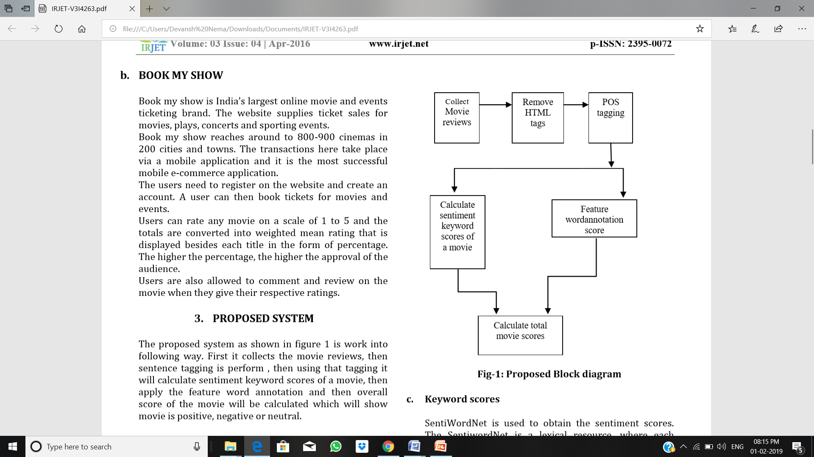

CHAPTER 2
LITERATURE SURVEY

2.1 Comparison of Four Text Classifiers on Movie Reviews.

Text Categorization has been playing an important role in the ﬁelds of information retrieval, machine learning, natural language processing, and others. In this paper four principles of classiﬁcation algorithm are used which are Decision Tree classiﬁcation, Naive Bayes classiﬁcation, Maximum Entropy classiﬁcation and K-nearest neighbor classiﬁcation. This article introduces and compares four text categorization algorithms in analyzing the performance of each algorithm through experiments on the text of movie reviews. The classiﬁcation accuracy of Naïve Bayes algorithm on the text.
movie reviews is the best of the four classiﬁers as shown by the experimental result; the classiﬁcation rate of K-Nearest neighbor algorithm on the text movie reviews is the fastest; the Decision Tree algorithm is the most stable classiﬁcation. Taking all performance in consideration, when to classify the text of movie reviews, Naïve Bayes classiﬁcation algorithm is a best choice. It is not only fast and has high precision of classiﬁcation, which will have certain signiﬁcance on this type of text categorization.

Disadvantages: The accuracy was not good And the result are different every time.

2.2 Improving Sentiment Rating of Movie Review Comments for Recommendation

People usually ask for advises from their family, before making any decisions for example, watching movies, going to a restaurant, and buying smart phones. Author proposes two heuristic rules for lexicon adjustment. First, they identify and remove improper words that discuss the story or describe the roles, instead of judging the whole movie. For example, “kindhearted”, or “vicious”. Second, they include potential opinion words that are popular terms or buzz words commonly used in the social community. This will increase the lexicon size to get higher coverage. For example, “binge-watch” . Author also added, adjectives that are opinionated for judging the movie, such as “amazing”, and “off-putting”. In this paper, author presented heuristic rules to adjust sentiment lexicons, and proposed opinion rating aggregation methods for movie recommendation. From the experimental results, we can see good accuracy of sentiment classiﬁcation in movie reviews for recommending popular movies. Future application to other domains of review comments is possible.

Disadvantages: Lots of human calculation are needed. The end result was not so good.

2.3 Sentiment Analysis of Movie Reviews Using Heterogeneous Features

Since early 2000, In Data Mining and Natural Language Processing (NLP) sentiment analysis is the most vigorous research areas. In this paper the author proposed hybrid approach for system identiﬁed sentiment orientation from review text documents. The combination of Machine learning and Lexicon-based (knowledge-based) approach is known as hybrid approach. The proposed approach has major ﬁve components, that are movie review data set, preprocessing, features selection and extraction, classiﬁcation algorithms and sentiment tpolarity. As an input, manually created movie review text documents are used, but when we collect the data from the web there are many irrelevant and unprocessed data, so they need to preprocess using different preprocessing techniques than feature selection and extraction would be done. Author conclude that using these heterogeneous features we can get better results rather than using only machine learning or lexicon based features and also using the Naive Bayes algorithm achieved tremendous accuracy even in a small amount of training data as especially compared with Linear SVM for these heterogeneous features.

Disadvantages:
Naive Bayes classifier makes a very strong assumption on the shape of your data distribution, i.e. any two features are independent given the output class.

2.4 Analyses of movie reviews using lexicon approach

In this paper they use aspect level analysis which is more appropriate solution for more complete and accurate system. All slang as well as informer words are replaced with proper words. For example if any review consist of word congrats then with the help of pre-processing it will get converted with word congratulations. By using machine learning and sentiWordNet they categorized subjective and objective sentences and use Part-Of-Speech tag to ﬁnd out category of the word and tag the words according to noun. Opinion pair and output features are ﬁnding out by using ruled based system, and they are categorized into neutral, positive or negative. Rule based system which allows user to easily check different aspect of movie liked or disliked by other user. Now summary generator use extracted opinion and Summery generator module exploits each feature-opinion pair to ﬁnd polarity and generates summarized review. In this paper they have implements two different methods to ﬁnd subjectivity of sentences. Among these two methods, Naïve Bayes classiﬁer gives more accurate result than SentiWordNet.

Disadvantages:
They used naïve Bayes which have a problem of strong assumption on the shape of your data distribution.
2.5 Sentiment Classiﬁcation of Film Reviews Using IB1

Oswin Rahadiyan H and his team uses IB1 (Instance Based Learning 1) because of its simplicity and accuracy. WordNet component also used to expand the similar words on database. This study uses Vector Space model to implement Instance-Based Learning: IB1 which is using TF-IDF weighting scheme and Cosine similarity function. In this paper they have enhancing the performance of Sentiment Analysis by Using Different Feature Combinations and By using IB1 algorithm, they have achieved performance above average which is about 65% to 95%.

Disadvantages:
Long documents are poorly represented because they have poor similarity values.

2.6 Enhancing the Performance of Sentiment Analysis by Using Different Feature Combinations

In this paper Nazma Iqbal and her team proposed a modularized polarity classiﬁcation system for Sentiment Analysis using three Machine Learning techniques. They have used unigram and bigram features which are most informative features. Here Naive Bayes, Support Vector Machine and Maximum Entropy is used for higher and more optimal than single feature selection model. And this paper addresses the task of document-level and sentence-level Sentiment Analysis in two different domains which help them to improve their performance and to reach to optimum level and the proposed system analyses the micro blogging messages based on several feature combinations schemes to determine the best combination sets for Sentiment Analysis.

Disadvantages:
Theoretically assumes terms are statistically independent.
Semantic sensitivity; documents with similar context but different term vocabulary won't be associated, resulting in a "false negative match".

2.7 Sentiment analyis of Indian movie review with various feature selection techniques

In this paper they have used various feature selection techniques. Bayesian Classiﬁer has been used in this study for testing feature selection mechanics which is one of the best machine learning algorithms and gives optimized result. This classiﬁer is trained on the words/features of the corpus extracted, and they have used ﬁve different feature selection algorithms,andtheyareChi-squaretest,Info-gain,Gain-Ratio, One-R and relief attribute. A comparative study has been performed amongst them and the learning capability of the classiﬁers was improved. With the help of Bayesian classiﬁer they have performed a comparative analysis between feature selections. They have achieved their aim by analyzing the opinion of the different users with the help of different models.

Disadvantages:
It turns out that specifying a prior is extremely difficult.

2.8 Sentiment analysis of movie review data using Senti-lexicon algorithm

In this paper Deebha Mumtaz and Bindiya Ahuja have proposed the Senti-lexical algorithm to ﬁnd the polarity of a review as positive, negative or neutral. By using Document level mining, Sentence level mining, Entity level mining they have obtained more reﬁned features sets about a review and by which overall performance of the system is increased and optimized. And they have used a bank of positive, negative and negation words and emoticons and by opinion mining they have described its scope, levels, and types of the review. This system for sentiment analysis based on lexical technique and by compared to other machine learning algorithms, Sentilexicon algorithm proves to be more simple, versatile and feasible.

Disadvantages:
As it is a rule based model lots of computation is needed.
Its difficult to implement

2.9 SentReP: Sentiment Classiﬁcation of Movie Reviews using Efﬁcient Repetitive Pre-Processing

Asha S Manek and her team proposed a model based on Sentiment Classiﬁcation of Movie Reviews using Efﬁcient Repetitive Pre-processing (SentReP), which is based on tested parameters and a focused pre-processing technique to classify opinions. In this paper they are more focused on removing the spam reviews from the dataset are more prior as it increases the accuracy of the system. To obtain tokenized word list they emphasize on pre-processing technique. And they have used different machine learning algorithm to test SentRep which are K-NN, Naïve Bayes, SVM Linear and SVM Stratiﬁed classiﬁers across different movie review data set with different sizes. According to their study and experiment they have proved that SVM Linear algorithm give the best results and performance with an accuracy of 97.25%.

Disadvantages:
They came up with Naïve Bayes being the best algorithm among the others but Naïve Bayes have lots of disadvantage such as data scarcity

2.10 Aspect Based Sentiment Analysis of Movie Reviews: Finding the Polarity Directing Aspects

In understanding the sentiment conveyed by the user towards the movie, sentiment analysis of a movie review plays an important role. In order to ﬁnd out the aspect speciﬁc driving factors author focus on aspect based sentiment analysis of movie reviews. In this paper author propose a method to ﬁnd out the aspects that dictate the sentiment score of the review the most. For this purpose they tend to use some “driving factors” which give weightage to different aspects of the movie. Thus, the overall score of the document is the sum of individual aspect scores weighed by their driving factors. Each word in the lexicon will have a different positive and negative score based on the context (genre) in which it was used. The experiment was conducted to ﬁnd which movie aspects inﬂuence the orientation of the review using driving factors. It concluded with Movie, Acting and Plot aspects getting overall high driving factors and resulting in an accuracy of 79.372% for the current dataset in consideration. The importance of these aspects may or may not change, but since the experiments were conducted on a large dataset, it is quite unlikely that it would.

Disadvantages:
Language cannot be simply divided into different units in real life.
Some topics that are traditionally considered advanced can actually be taught at much loser levels
CHAPTER 3
MODULES DESCRIPTION

3.1 Dataset
- A data set (or dataset) is a collection of data. Most commonly a data set corresponds to the contents of a single database table, or a single statistical data matrix, where every column of the table represents a particular variable, and each row corresponds to a given member of the data set in question. The data set lists values for each of the variables, such as height and weight of an object, for each member of the data set. Each value is known as a datum. The data set may comprise data for one or more members, corresponding to the number of rows.
- This is a dataset for binary sentiment classification containing substantially more data than previous benchmark datasets. it provides a set of 25,000 highly polar movie reviews for training, and 25,000 for testing. There is additional unlabeled data for use as well. Raw text and already processed bag of words formats are provided.
- The dataset is compiled from a collection of 50,000 reviews from IMDB on the condition there are no more than 30 reviews per movie. The numbers of positive and negative reviews are equal. Negative reviews have scores less or equal than 4 out of 10 while a positive review have score greater or equal than 7 out of 10. Neutral reviews are not included. The 50,000 reviews are divided evenly into the training and test set.

3.2 Artificial Neural Network (ANN)
- An Artificial Neural Network (ANN) is an information processing paradigm that is inspired by the way biological nervous systems, such as the brain, process information. The key element of this paradigm is the novel structure of the information processing system. It is composed of a large number of highly interconnected processing elements (neurones) working in unison to solve specific problems. ANNs, like people, learn by example. An ANN is configured for a specific application, such as pattern recognition or data classification, through a learning process. Learning in biological systems involves adjustments to the synaptic connections that exist between the neurons. This is true of ANNs as well.
- Neural networks, with their remarkable ability to derive meaning from complicated or imprecise data, can be used to extract patterns and detect trends that are too complex to be noticed by either humans or other computer techniques. A trained neural network can be thought of as an "expert" in the category of information it has been given to analyse.

CHAPTER 4
EXISTING SYSTEM

Sentimental analysis is an emerging ﬁeld of study. Many works have been done previously in this ﬁeld. All the previous works done in this ﬁeld were mainly concerned with lexicon. Few projects also include ﬁnding the meaning of sentences
Which is basically slow process and can contribute in improving the performance. On the other hand, in some of the papers, they used hybrid algorithm and they all work well but lack efficiency. They have used naïve bayes classification in which the result is good but the main problem is that accuracy was not good and there are lots of assumption on which results are based and the result outcome was different all the time.

In lexicon sentimental analysis lots of human calculation are needed or required and the end result are not that good as expected from the system and with lexicon the possibility of human error increase and that affect the result. Some of the hybrid algorithm that are used previously are combination of lexicon with naive bayes which uses very strong assumption on the shape of data distribution, i.e. any two features are independent given the output class.

Some uses machine learning algorithm with sentiWordnet which is again based on naïve bayes algorithm which uses strong assumption. In some previous they used vector space model that is instance based learning that is also known as IB using IDF.
But the problem is that the long documentation are poorly represented because they have poor similarities.

In 2018 they combine naïve bayes with support Vector Machine and Maximum Entropy but in that the main problem is Theoretically assumes terms are statistically independent.Semantic sensitivity; documents with similar context but different term vocabulary won't be associated, resulting in a "false negative match".

Senti-lexical algorithm give good result but problem with is that it is a rule based model lots of computation is needed. It’s difficult to implement. Some combine three algorithm K-NN, Naïve Bayes, SVM Linear for better result but they came up with Naïve Bayes being the best algorithm among the others but Naïve Bayes have lots of disadvantage such as data scarcity. And the problem with Lexicon method is that Language cannot be simply divided into different units in real life.Some topics that are traditionally considered advanced can actually be taught at much loser levels

3.1 Disadvantages

In today’s worlds when there is any services or product has to buy, we first check for the reviews online but there are thousands of reviews that are available online and it is difficult for all the users and customers to go through all the reviews. And that’s the problem of existing system that it lack in the satisfaction of user and consume more time for user and the system is not well optimized. Most of the hybrid algorithm are not efficient and consume more resources then required.

S.NO | TITLE | YEAR | ALGORITHM | DISADVANTAGES
1. | Comparison of Four Text Classifiers on Movie Reviews | 2015 | Naive Bayes Classifier | The accuracy was not good And the result are different every time.
2. | Improving Sentiment Rating of Movie Review Comments for Recommendation | 2017 | Lexical Sentiment Analysis | Lots of human calculation are needed. The end result was not so good
3. | Sentiment Analysis of Movie Reviews Using Heterogeneous Features | 2018 | Lexicon with Naive Bayes | Naive Bayes classifier makes a very strong assumption on the shape of your data distribution, i.e. any two features are independent given the output class.
4. | Analysis of movie reviews using lexicon approach | 2015 | Machine learning and sentiWordNet | They used naïve Bayes which have a problem of strong assumption on the shape of your data distribution.
5. | Sentiment Classiﬁcation of Film Reviews Using IB1 | 2016 | Vector Space model Instance-Based Learning: IB1 using TF-IDF | Long documents are poorly represented because they have poor similarity values.
6. | Enhancing the Performance of Sentiment Analysis by Using Different Feature Combinations | 2018 | Naive Bayes, Support Vector Machine and Maximum Entropy | Theoretically assumes terms are statistically independent.  Semantic sensitivity; documents with similar context but different term vocabulary won't be associated, resulting in a "false negative match".
7. | Sentiment analysis of Indian movie review with various feature selection techniques | 2016 | Bayesian Classiﬁer | It turns out that specifying a prior is extremely difficult.
8. | Sentiment analysis of movie review data using Senti-lexicon algorithm | 2016 | Senti-lexical algorithm | As it is a rule based model lots of computation is needed.  Its difficult to implement.
9. | SentReP: Sentiment Classiﬁcation of Movie Reviews using Efﬁcient Repetitive Pre-Processing | 2013 | K-NN, Naïve Bayes, SVM Linear | They came up with Naïve Bayes being the best algorithm among the others but Naïve Bayes have lots of disadvantage such as data scarcity
10. | Aspect Based Sentiment Analysis of Movie Reviews: Finding the Polarity Directing Aspects | 2014 | Lexicon method | Language cannot be simply divided into different units in real life.Some topics that are traditionally considered advanced can actually be taught at much loser levels

CHAPTER 5
PROPOSED SYSTEM

In today’s world other opinion matter most in every field, whether we have to buy any service or product. And there are thousands of reviews available online but no one classified those reviews and so we proposed a system where we can cumulate all the reviews available online and combine them and produce a single output for the end user for better understanding of reviews.

For the training of the machine which work on Artificial Neural Network we use IMDB dataset with twenty five thousands set of reviews which are bipolar in nature which means they contain positive as well as negative reviews. We split the reviews for training and testing of machine and as all the reviews or datasets are labeled, we can easily calculate the efficiency of machine. While training the machine we tried 4 different type of activation function those are sigmoid or logistic activation function, Tanh or hyperbolic tangent Activation Function, ReLU (Rectified Linear Unit) Activation Function, ArcTan Activation Function which give different results.
And with every activation function the result differs and we also using three different learning rates that are 0.1, 0.01, 0.001 and the accuracy increases as we train our system with respective learning rates. As slowly as we train the system the accuracy will be better.

In our project, we try and develop a system which helps the end users or customers to select the services or products that are suitable for their needs and their experience can be great while using their selected services or products. After the training of our machine we tested machine with different activation function and each give different result and accuracy. We use python for web crawling to extract data from imdb website and after that we filter the data and feed that to machine for testing and produce the result giving numbers of positive reviews and negative reviews and the rating for the movies according to the movie reviews.

5.1 Advantages

- We have used Artificial Neural Network which work pretty well to train our machine over 1 lakh lines or sentences. It is very efficient and give great performance.
- Artificial Neural Network with 10 internal nodes gives better and better result while training our machine and produces word corpus very well.
- Adaptive learning: An ability to learn how to do tasks based on the data given for training or initial experience.
- Self-Organisation: An ANN can create its own organisation or representation of the information it receives during learning time.
- Real Time Operation: ANN computations may be carried out in parallel, and special hardware devices are being designed and manufactured which take advantage of this capability.
- Fault Tolerance via Redundant Information Coding: Partial destruction of a network leads to the corresponding degradation of performance. However, some network capabilities may be retained even with major network damage.

5.2 Hardware Requirements
Hardware Requirements are:
• System: Intel core i5.
• Hard Disk: 500 GB.
• Monitor: 15 VGA Color.
• Mouse: Logitech.
• Keyboard: Logitech
• Ram: 8 GB.
• Wi-Fi modem.
• Wi-Fi Router.
• Internet connection

5.3 Software Requirements
Software Requirements are:
• Operating system: Windows 10.
• Coding Language: Python 3.7.
• Anaconda.
• Jupiter notebook.
• Google Chrome.

CHAPTER 6
SYSTEM ANALYSIS

For making a system the most important thing is analyzing the existing system as well as the proposed system. Today the demand of efficient and accurate system are increasing day by day. This is because we are not following the correct norms and we the reviewing system which we follow is very old. So to improve this we analysed the old system and make certain changes in our proposed system. This will make our system more accurate and efficient and will make our reviewing system more fruitful and helpful for users.

Requirement Analysis:
There are many analysis but starting from a raw fruit we always need the seed from where it has grown and which land is fruitful and helpful for it for mass growing. So the system should be such, that it could run on the minimum specialization after all reviewing needs to be divided into equal parts and its the right of everyone to make use of it. So the main thing is hardware and software requirements we made the use of latest software and used Python which is very fast and easy to access. This helped us in providing more accurate results. No special hardware is used and our system is so compatible that it can be run even the processors which we used a decade before or more.

Design Analysis:
It is of importance that design of a system must be easy to read and understandable by everyone. Design analysis is important because it has been said that visuals play a very important role in day to day life and are most understandable. Even it is said that by using visuals a person understands 70% more as compared to other means. So we focused on designed and made it very easy.

CHAPTER 7
SYSTEM DESIGN

Machine Learning Algorithm
Artificial neural networks
An Artificial Neural Network (ANN) is an information processing paradigm that is inspired by the way biological nervous systems, such as the brain, process information. The key element of this paradigm is the novel structure of the information processing system. It is composed of a large number of highly interconnected processing elements (neurons) working in unison to solve specific problems. ANNs, like people, learn by example. An ANN is configured for a specific application, such as pattern recognition or data classification, through a learning process. Learning in biological systems involves adjustments to the synaptic connections that exist between the neurones. This is true of ANNs as well.
Neural networks, with their remarkable ability to derive meaning from complicated or imprecise data, can be used to extract patterns and detect trends that are too complex to be noticed by either humans or other computer techniques.
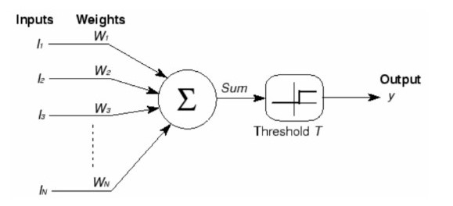
|
Figure 1
|
ANN Architecture
|
|

Trained neural network can be thought of as an "expert" in the category of information it has been given to analyze.
Activation Function
It’s just a thing function that you use to get the output of node. It is also known as Transfer Function. It’s just a thing function that you use to get the output of node. It is also known as Transfer Function.
The Activation Functions can be basically divided into 2 types-
Linear Activation Function
Non-linear Activation Function
Linear or Identity Activation Function
As you can see the function is a line or linear. Therefore, the output of the functions will not be confined between any ranges.

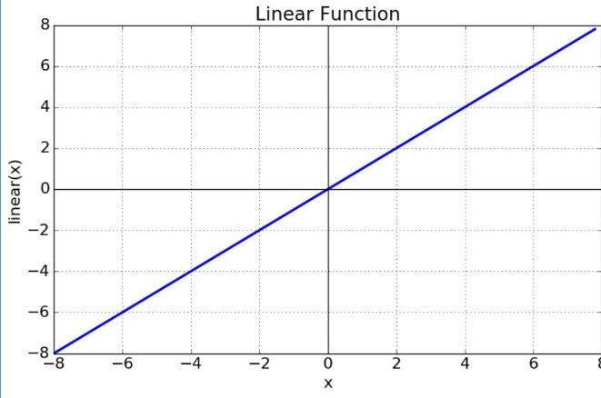
|
Figure 2
|
Linear function graph
|

|
Equation: f(x) = x
Range: (-infinity to infinity)
Non-linear Activation Function
The Nonlinear Activation Functions are the most used activation functions. Nonlinearity helps to makes the graph look something like this

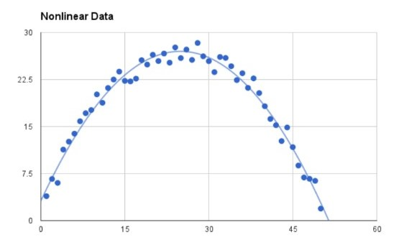
|
Figure 3
|
Non-linear function graph
|
|
It makes it easy for the model to generalize or adapt with variety of data and to differentiate between the outputs
Sigmoid or Logistic Activation Function
The Sigmoid Function curve looks like an S-shape.

The main reason why we use sigmoid function is because it exists between (0 to 1).

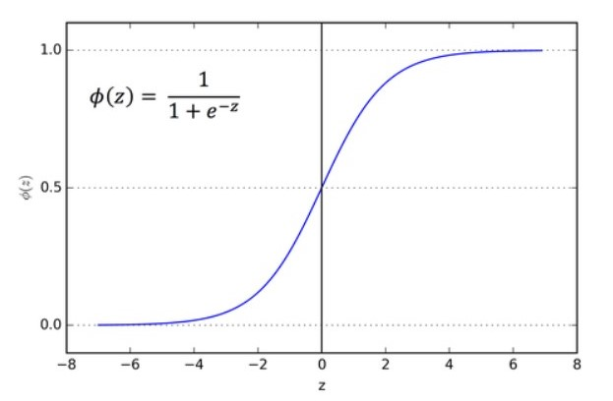
|
Figure 4
|
Sigmoid function graph
|
|

Therefore, it is especially used for models where we have to predict the probability as an output. Since probability of anything exists only between the range of 0 and 1, sigmoid is the right choice.
The function is differentiable. That means, we can find the slope of the sigmoid curve at any two points. The function is monotonic but function’s derivative is not.
Tanh or hyperbolic tangent Activation Function
tanh is also like logistic sigmoid but better. The range of the tanh function is from (-1 to 1). tanh is also sigmoidal (s - shaped).

The advantage is that the negative inputs will be mapped strongly negative and the zero inputs will be mapped near zero in the tanh graph. The function is differentiable.

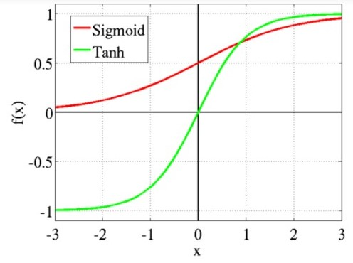
|
Figure 5
|
Tanh function graph
|
|
The advantage is that the negative inputs will be mapped strongly negative and the zero inputs will be mapped near zero in the tanh graph. The function is differentiable.
The function is monotonic while its derivative is not monotonic.
ReLU (Rectified Linear Unit) Activation Function
The ReLU is the most used activation function in the world right now. Since, it is used in almost all the convolutional neural networks or deep learning.

As you can see, the ReLU is half rectified (from bottom). f(z) is zero when z is less than zero and f(z) is equal to z when z is above or equal to zero.

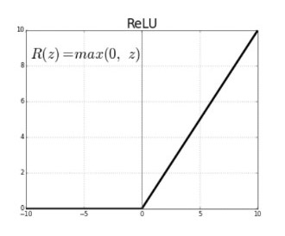
|
Figure 6
|
ReLU function graph
|
|
As you can see, the ReLU is half rectified (from bottom). f(z) is zero when z is less than zero and f(z) is equal to z when z is above or equal to zero.
Range: [ 0 to infinity]
The function and its derivative both are monotonic.But the issue is that all the negative values become zero immediately which decreases the ability of the model to fit or train from the data properly. That means any negative input given to the ReLU activation function turns the value into zero immediately in the graph, which in turns affects the resulting graph by not mapping the negative values appropriately.
ArcTan Activation Function
This activation function maps the input values in the range (− π /2 , π /2 ) ). Its derivative converges quadratically against zero for large input values. On the other hand, in the sigmoid activation function, the derivative converges exponentially against zero, which can cause problems during back-propagation.

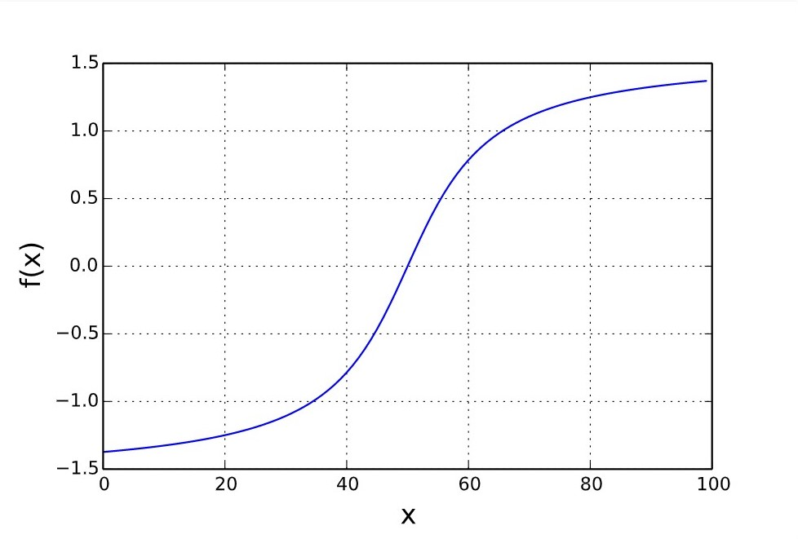
|
Figure 7
|
Arctan function graph
|
|
Its graph is slightly flatter than tanh tanh, so it has a better tendency to differentiate between similar input values.

CHAPTER 8
SAMPLE CODE

CHAPTER 9
RESULT AND DISCUSSIONS

9.1 Screenshots

CHAPTER 10
CONCULSION AND FUTURE WORK

Research in semantic analysis has grown significantly in the past few years. It is the emerging field in data mining and Natural Language Processing (NLP) which requires much deeper insight. The relevant works done to solve this problem could be studied through the project. In this project it is seen that sentiment analysis play vital role to make decision about movies. In this paper we introduce Artificial Neural Network (ANN). For the future work, we would love to evaluate this method on much large movie review data sets for greater results.

REFERANCES

[1] Lopamudra Dey, Sanjay Chakraborty, Anuraag Biswas, Beepa Bose, Sweta Tiwari “Sentiment Analysis of Review Datasets using Naïve Bayes’ and K-NN Classifier”. Issue 31-oct-2016

[2] Lina L. Dhande and Dr. Prof. Girish K. Patnaik, “Analyzing Sentiment of Movie Review Data using Naive Bayes Neural Classifier”, IJETTCS, Volume 3, Issue 4 July-August 2014, ISSN 2278-6856.

[3] P.Kalaivani, “Sentiment Classification of Movie Reviews by supervised machine learning approaches” et.al,Indian Journal of Computer Science and Engineering (IJCSE) ISSN : 0976-5166 Vol. 4 No.4 Aug-Sep 2013.

[4] Meena Rambocas, João Gama, “Marketing Research: The Role of Sentiment Analysis”, April 2013, ISSN: 0870-8541.

[5] Weiguo Fan, Linda Wallace, Stephanie Rich, and Zhongju Zhang, “Tapping into the Power of Text Mining”, Journal of ACM, Blacksburg, 2005.

[6] “Movie review dataset,” [Online]. Available http://www.cs.cornell.edu/people/pabo/movie-reviewdata/, [Accessed: October 2013].

[7] K. M. Leung, “Naive Bayesian classifier,” [Online] Available: http://www.sharepdf.com/81fb247fa7c54680a94dc0f3a 253fd85/naiveBayesianClassifier.pdf, [Accessed: September 2013].

APPENDIX
Note: Include Coding and Screen shot of the project in the appendix (40% code)

def pretty_print_review_and_label(i):
print(labels[i] + "\t:\t" + reviews[i][:80] + "...")

g = open('reviews.txt','r') # What we know!
reviews = list(map(lambda x:x[:-1],g.readlines()))
g.close()

g = open('labels.txt','r') # What we WANT to know!
labels = list(map(lambda x:x[:-1].upper(),g.readlines()))
g.close()
print("labels.txt \t : \t reviews.txt\n")
pretty_print_review_and_label(2137)
pretty_print_review_and_label(12816)
pretty_print_review_and_label(6267)
pretty_print_review_and_label(21934)
pretty_print_review_and_label(5297)
pretty_print_review_and_label(4998)

from collections import Counter
import numpy as np
positive_counts = Counter()
negative_counts = Counter()
total_counts = Counter()
for i in range(len(reviews)):
if(labels[i] == 'POSITIVE'):
for word in reviews[i].split(" "):
positive_counts[word] += 1
total_counts[word] += 1
else:
for word in reviews[i].split(" "):
negative_counts[word] += 1
total_counts[word] += 1
positive_counts.most_common()
pos_neg_ratios = Counter()

for term,cnt in list(total_counts.most_common()):
if(cnt > 100):
pos_neg_ratio = positive_counts[term] / float(negative_counts[term]+1)
pos_neg_ratios[term] = pos_neg_ratio

for word,ratio in pos_neg_ratios.most_common():
if(ratio > 1):
pos_neg_ratios[word] = np.log(ratio)
else:
pos_neg_ratios[word] = -np.log((1 / (ratio+0.01)))

# words most frequently seen in a review with a "POSITIVE" label
pos_neg_ratios.most_common()
# words most frequently seen in a review with a "NEGATIVE" label
list(reversed(pos_neg_ratios.most_common()))[0:30]

from IPython.display import Image

review = "This was a horrible, terrible movie."

Image(filename='sentiment_network.png')

review = "The movie was excellent"

Image(filename='sentiment_network_pos.png')

try:
import urllib.request as urllib2
except ImportError:
import urllib2
from bs4 import BeautifulSoup
from nltk.tokenize import sent_tokenize, word_tokenize
from nltk.corpus import stopwords
from string import punctuation
import nltk

word_sent = word_tokenize(reviews[5].lower())
print(word_sent)
_stopwords = set(stopwords.words('english') + list(punctuation))
print(_stopwords)
word_sent =[word for word in word_sent if word not in _stopwords]
print(word_sent)
vocab = set(total_counts.keys())
vocab_size = len(vocab)
print(vocab_size)
list(vocab)
import numpy as np

layer_0 = np.zeros((1,vocab_size))
layer_0

from IPython.display import Image
Image(filename='sentiment_network.png')

word2index = {}

for i,word in enumerate(vocab):
word2index[word] = i
word2index
def update_input_layer(review):

global layer_0

# clear out previous state, reset the layer to be all 0s
layer_0 *= 0
for word in review.split(" "):
layer_0[0][word2index[word]] += 1

update_input_layer(reviews[0])
def get_target_for_label(label):
if(label == 'POSITIVE'):
return 1
else:
return 0

Building a Neural Network
import time
import sys
import numpy as np

# Let's tweak our network from before to model these phenomena
class SentimentNetwork:
def __init__(self, reviews,labels,hidden_nodes = 10, learning_rate = 0.1):

# set our random number generator
np.random.seed(1)

self.pre_process_data(reviews, labels)

self.init_network(len(self.review_vocab),hidden_nodes, 1, learning_rate)

def pre_process_data(self, reviews, labels):

review_vocab = set()
for review in reviews:
for word in review.split(" "):
review_vocab.add(word)
self.review_vocab = list(review_vocab)

label_vocab = set()
for label in labels:
label_vocab.add(label)

self.label_vocab = list(label_vocab)

self.review_vocab_size = len(self.review_vocab)
self.label_vocab_size = len(self.label_vocab)

self.word2index = {}
for i, word in enumerate(self.review_vocab):
self.word2index[word] = i

self.label2index = {}
for i, label in enumerate(self.label_vocab):
self.label2index[label] = i

def init_network(self, input_nodes, hidden_nodes, output_nodes, learning_rate):
# Set number of nodes in input, hidden and output layers.
self.input_nodes = input_nodes
self.hidden_nodes = hidden_nodes
self.output_nodes = output_nodes

# Initialize weights
self.weights_0_1 = np.zeros((self.input_nodes,self.hidden_nodes))

self.weights_1_2 = np.random.normal(0.0, self.output_nodes**-0.5,
(self.hidden_nodes, self.output_nodes))

self.learning_rate = learning_rate

self.layer_0 = np.zeros((1,input_nodes))

def update_input_layer(self,review):

# clear out previous state, reset the layer to be all 0s
self.layer_0 *= 0
for word in review.split(" "):
if(word in self.word2index.keys()):
self.layer_0[0][self.word2index[word]] += 1

def get_target_for_label(self,label):
if(label == 'POSITIVE'):
return 1
else:
return 0

def sigmoid(self,x):
return 1 / (1 + np.exp(-x))

def sigmoid_output_2_derivative(self,output):
return output * (1 - output)

def train(self, training_reviews, training_labels):

assert(len(training_reviews) == len(training_labels))

correct_so_far = 0

start = time.time()

for i in range(len(training_reviews)):

review = training_reviews[i]
label = training_labels[i]

#### Implement the forward pass here ####
### Forward pass ###

# Input Layer
self.update_input_layer(review)

# Hidden layer
layer_1 = self.layer_0.dot(self.weights_0_1)

# Output layer
layer_2 = self.sigmoid(layer_1.dot(self.weights_1_2))

#### Implement the backward pass here ####
### Backward pass ###

# Output error
layer_2_error = layer_2 - self.get_target_for_label(label) # Output layer error is the difference between desired target and actual output.
layer_2_delta = layer_2_error * self.sigmoid_output_2_derivative(layer_2)

# Backpropagated error
layer_1_error = layer_2_delta.dot(self.weights_1_2.T) # errors propagated to the hidden layer
layer_1_delta = layer_1_error # hidden layer gradients - no nonlinearity so it's the same as the error

# Update the weights
self.weights_1_2 -= layer_1.T.dot(layer_2_delta) * self.learning_rate # update hidden-to-output weights with gradient descent step
self.weights_0_1 -= self.layer_0.T.dot(layer_1_delta) * self.learning_rate # update input-to-hidden weights with gradient descent step

if(np.abs(layer_2_error) < 0.5):
correct_so_far += 1

reviews_per_second = i / float(time.time() - start)

sys.stdout.write("\rProgress:" + str(100 * i/float(len(training_reviews)))[:4] + "% Speed(reviews/sec):" + str(reviews_per_second)[0:5] + " #Correct:" + str(correct_so_far) + " #Trained:" + str(i+1) + " Training Accuracy:" + str(correct_so_far * 100 / float(i+1))[:4] + "%")
if(i % 2500 == 0):
print("")

def test(self, testing_reviews, testing_labels):

correct = 0

start = time.time()

for i in range(len(testing_reviews)):
pred = self.run(testing_reviews[i])
if(pred == testing_labels[i]):
correct += 1

reviews_per_second = i / float(time.time() - start)

sys.stdout.write("\rProgress:" + str(100 * i/float(len(testing_reviews)))[:4] \
+ "% Speed(reviews/sec):" + str(reviews_per_second)[0:5] \
+ "% #Correct:" + str(correct) + " #Tested:" + str(i+1) + " Testing Accuracy:" + str(correct * 100 / float(i+1))[:4] + "%")

def run(self, review):

# Input Layer
self.update_input_layer(review.lower())

# Hidden layer
layer_1 = self.layer_0.dot(self.weights_0_1)

# Output layer
layer_2 = self.sigmoid(layer_1.dot(self.weights_1_2))

if(layer_2[0] > 0.5):
return "POSITIVE"
else:
return "NEGATIVE"

mlp = SentimentNetwork(reviews[:-1000],labels[:-1000], learning_rate=0.1)
# train the network
mlp.train(reviews[:-1000],labels[:-1000])

# evaluate our model before training (just to show how horrible it is)
mlp.test(reviews[-1000:],labels[-1000:])

